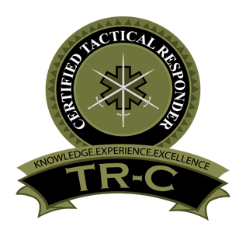
To: [Enter commander’s name here]

From: [Enter your name and title here]
Date: [Enter today’s date]
Subject: Request to sit for Certified Tactical Responder Examination
I would like to obtain my Certified Tactical Responder (TR-C) credential from the International Board of Specialty Certification (IBSC). The TR-C exam was developed to validate my knowledge to provide the best patient care in the tactical environment. The IBSC examination is the only specialty certification for tactical responders.
The expectation for the TR-C exam candidate is competency in casualty assessment, stabilization, and evacuation in hostile and austere environments in a non-paramedic function, as well as thorough familiarity with tactical principles, triage, and operational medicine. TR-C candidates are operators functioning within a team and commonly have a primary law enforcement role with a secondary medic role. The certification process is focused on decreasing preventable deaths at the point of wounding and is aligned with the three definitive phases of TECC/TCCC care. The questions on the examination are based on sound medical and tactical principles found in TECC, TCCC and endorsed by C-TEC.
The TR-C exam is priced at $195. By submitting this letter with your signature, I will receive a $20 discount off the examination fee.
This process will not only allow me to achieve this esteemed status but will provide an opportunity for me to demonstrate our department’s commitment to providing the best practices in the tactical environment. I am certain that this will provide a return on investment for our agency and for me professionally.
Commander’s Name and Title:
Department:
Commander’s Email:
Commander’s Signature:

After completing this form, please scan and return to aroy@ibsc.org
A refund in the amount of $20 will be returned to your original form of payment.

